Ames Housing
Regression problem
Outlier removal using Isolation Forests
# Last amended: 16th Sep, 2026
# My folder: C:\Users\ashok\OneDrive\Documents\anomaly_detection\isolationForest
# Reference file: ‘AmesHousing—numericOutlier’ in folder:
# C:\Users\ashok\OneDrive\Documents\anomaly_detection\numericOutliers
# Dataset: Kaggle
# Virtual Machine:
# GitHub: Clustering/anomaly_detection
In this documentation, we will refer to a Reference file as mentioned above.
We start from here
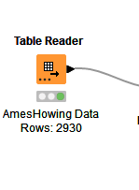

Data preprocessing:
Preprocess this dataset as in this reference file on my machine. Follow Chapter-I of the file to get a final pre-processing metanode.

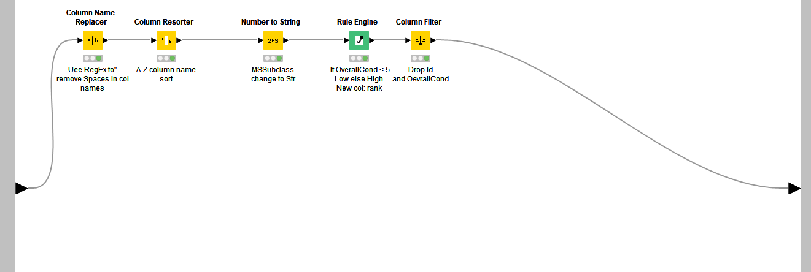
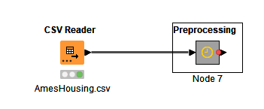

Chapter-II
Beginning Cross validation
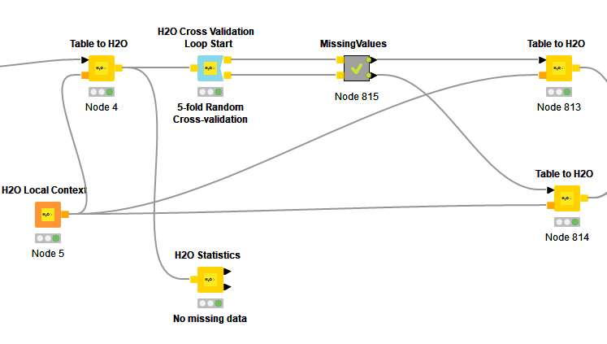
Figure 1: Missing values removal follows reference
Cross validation node: There is nothing special in its configuration. We have five-fold random sampling.
Missing Values Metanode: This node opens up as below:
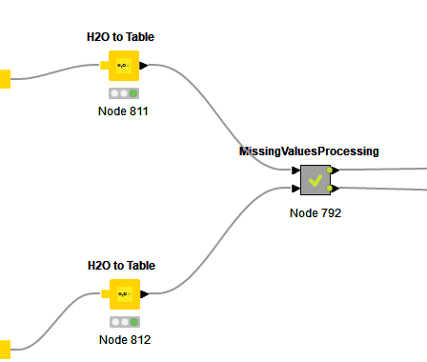
Figure 2: Missing values Processing is exactly the same as in Reference file.

Chapter-III
Cleaning outliers
The flow diagram is as below:
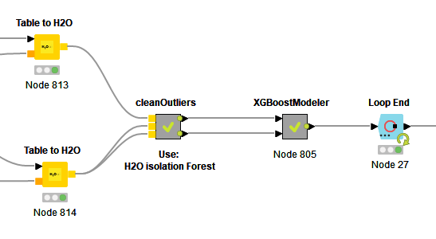
Clean outliers metanode opens as below:
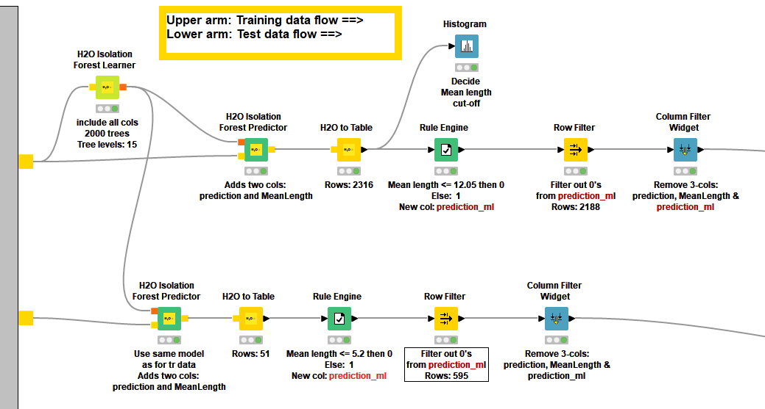
Figure 3: We have one H2o Isolation forest modeler but two predictors--One on each arm.
This flow diagram differs from the Reference file regarding how outliers are removed. In using isolation forests, we have to keep in mind that data is relatively large and we need stable trees.
- Number of levels (Tree depth): 15
- Number of models: 2000
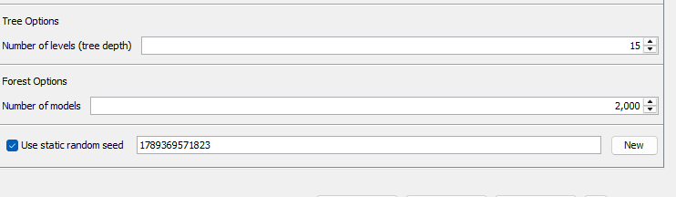
Figure 4: Isolation forest settings--I
- Algorithm Settings (tab) are as below:
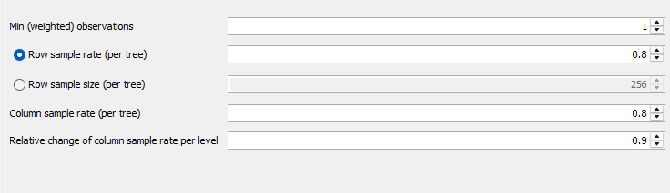
Figure 5: Isolation Forests Settings—II. Click Algorithm Settings tab and set these parameters to make it more robust.
- Predictor: No change in settings. Do it as per Reference.
The Mean Length histogram is as below:
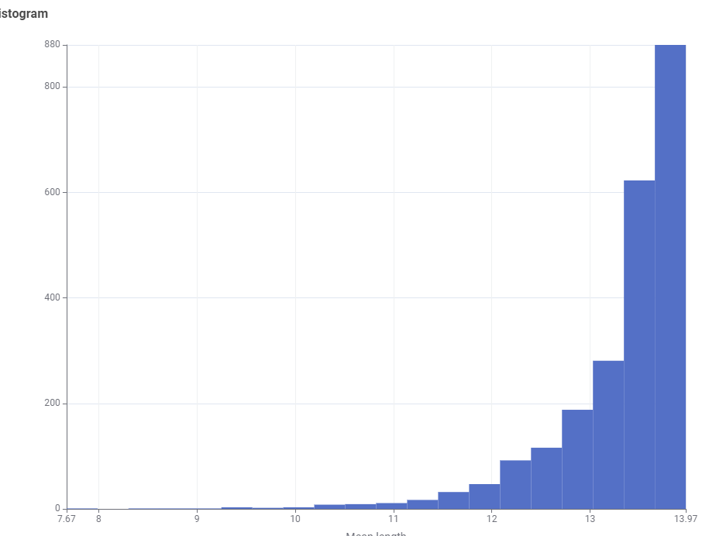
Accordingly, our rule engine is:
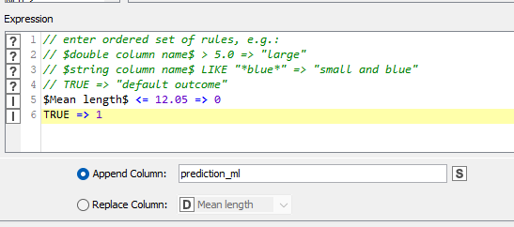
Figure 6: Rule Engine settings
Setting in the rest of nodes remain the same as in the Reference document.

Chapter-IV
Xgboost configuration
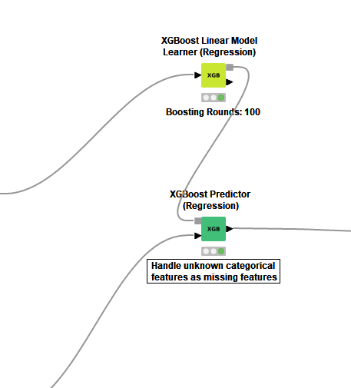
Configuration for predictor
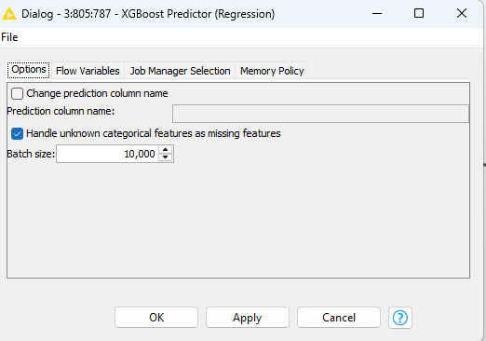
Figure 7: Check mark Handle unknown...

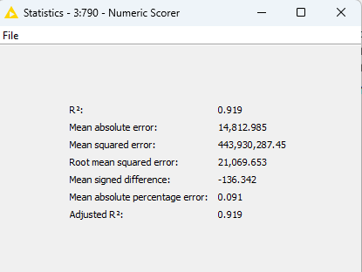

How to experiment:
To experiment, Set Mean Length to 0. This implies that there is no outlier filtering. Next, increase Mean Length. As you increase Mean Length, Mean Absolute Error goes on decreasing till around Mean Length of 12.05. And then goes on decreasing.
Mean Length < 0.01
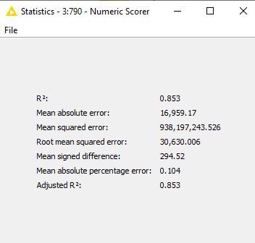
Mean Length < =2
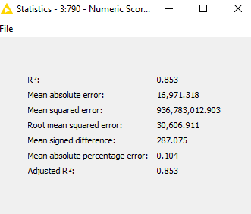
Mean Length <= 5
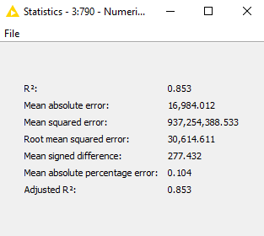
Mean Length <=10
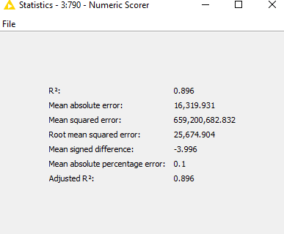
Mean Length <= 12
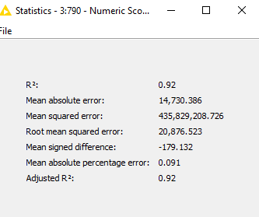
Mean Length < 13
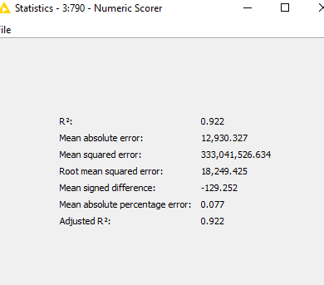
Mean Length < 14
No results. Empty table.
#######

